Title (and Subtitle if Applicable)
John Doe¹; Mary Doe^{1,2}; John Silva²
¹ Affiliation: Research Centre and / or University
² Affiliation: Research Centre and / or University
johndoe@mail.com; mary_doe@mail.com; john.silva@mail.pt
ABSTRACT
The abstract should briefly introduce the theme, the research objectives, the methodologies used, and the results obtained. It should have a length between 150 and 300 words. If the abstract is approved for oral presentation or poster, the author will be asked to submit a complete paper, minimum of 8 and a maximum of 12 pages, including all text and figures or tables, references, and notes. When preparing your paper please use APA referencing style. Please duplicate the styles (fonts, font sizes, spacing, headings, etc.) of your paper using this example.
Keywords
List of up to five keywords, separated by commas

INTRODUCTION
Identification of field and field of study, as well as the relevance and purpose of the work or research, presented clearly and explicitly. It is recommended to indicate the scope or context of the work or research implementation, among other data that offers a better work process or results understanding. The body of the paper must be written in Calibri, body 12, justified, without the entry of a paragraph and leading between spaces.
The paper must have a minimum length of 8 and a maximum of 12 pages. Care must be taken not to change the page settings, keeping the margins as they are in this model document.

1. Figures and Tables
They must appear centred on the page and numbered according to the example below. A descriptive title should be placed centred, above each table and below each figure (Calibri, body 10). The captions must be concise and the text of the tables must use the font Calibri, size 10.

1.1 Colours
Please check the quality of the images used (300 ppi) as, in case of acceptance of the paper, these will be printed in the event's book of proceedings.
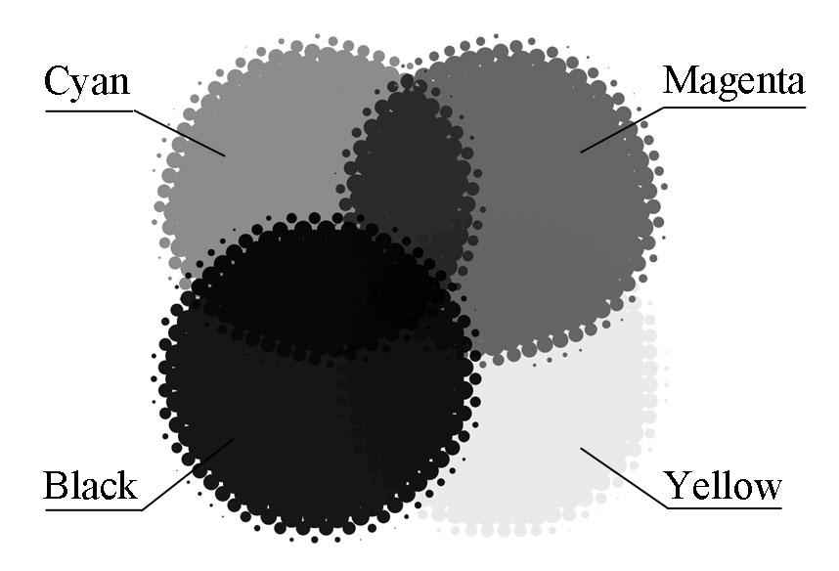
Figure 1 – Image subtitle (Calibri, body 10, centred)

2. Other aspects
Very important: before submitting the paper, rename the Word file to indicate the subarea to which it is associated, the first and last name of the first two authors (Example: editorial_design_joaosilva_manuelcarvalho.doc). If the same author sends more than one article to the same scientific area, they can add a digit at the end of the file name that differentiates them (Example: editorial_design_jonhdoe_maryjane_1.doc; Example: editorial_design_jonhdoe_maryjane_2.doc). Do not send pdf files, they must be sent in doc or docx extension.
The acknowledgments must appear near the bottom of the last page of the paper, as shown below and be written in Calibri, size 10, centred.

3. References
List of references used in the paper using the 7th edition of the APA standards, written in Calibri, size 12pts and justified.
Acknowledgments:
Work developed at the xxx research centre.

